Vessel Furnished Information
Vessel's Name
Port |  | Date |  | Time Zone: GMT + / −  Hrs
Call Sign |  | Draft F |  | Minimum depth
Nationality |  | Draft A |  | UKC available
Gross/Nett Tonnage |  | Draft Amidships |  | Displacement
Year Built |  | UKC  Required |  | Deadweight
LOA |  | Freeboard |  | Air Draft (Mast up)
Breadth |  | Bulbous Bow | Yes / No | Air Draft (Mast down)
 | Passing Over Head Bridge / Cable | Yes / No
No | Bridge Name / Cable | Vertical Clearance
1. |  | (m)
2. |  | (m)
3. |  | (m)
- Vertical Clearance = Height of O/H bridge or cable (lowest point from sea level) – Air draft (Mast up / Mast down)
- Calculate the vertical clearance for each individual bridge and cables to be transited (if more than one)
- If vessel passing more than 3 bridges / cables, fill up vertical clearance details in page 3 under “Other Important Details”.

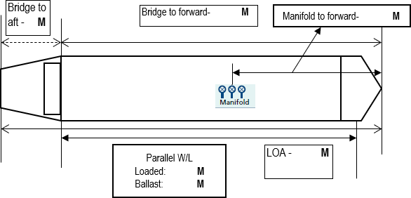

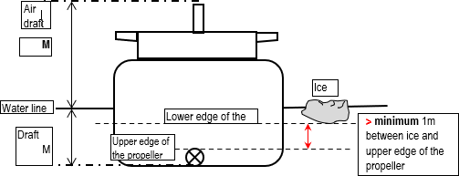
For Ice Covered Waters
Drafts required for the propleller immersion and fwd bow immersion for the vessel safe passage in Ice covered waters: |  |  |  | F |  | A |  |  |  | ICE belt drafts ( as applicable) |  |  |  |  |  | F(range) |  | A(range)
Vessel Inerted / Not Inerted / Gasfree / Not Gasfree / in Ballast / Loaded with:
Defects affecting manoeuvrability:
Navigational Aids
Compass system operational and ready |  |  |  |  | Yes / No |  |  |  |  | Constant gyro error + / − |  |  |  |  |  |  |  | degrees
Navigation lights Operational and Ready |  |  |  |  | Yes/ No
Is ECDIS primary means of navigation |  |  |  |  | Yes/No |  |  |  |  | No of ECDIS - ECDIS type -  Are ECDIS Operacional and Ready Yes/No
Is BNWAS operational |  |  |  |  | Yes/ No
Are the required flags hoisted |  |  |  |  | Yes/ No
Elec position fixing system operational and ready |  |  |  |  | Yes / No |  |  |  |  | Type
Echo Sounder operational and ready |  |  |  |  | Yes / No |  |  |  |  | Speed log operational and ready |  |  |  |  |  |  |  | Yes / No
 |  |  |  |  |  |  |  |  |  | Doppler |  |  |  |  |  |  |  | Yes / No
Transducer: |  |  |  |  | Forward / Aft |  |  |  |  | If Doppler log: Water speed / Ground speed / Dual Axis
Radars operational and ready |  |  | X Band (3 cm) |  | Yes / No |  |  |  |  | Indicators operational / ready |  |  |  | RPM / Pitch |  |  |  | Yes / No
 |  |  | S Band (10cm) |  | Yes / No |  |  |  |  |  |  |  |  | Rudder Angle |  |  |  | Yes / No
 |  |  | ARPA |  | Yes / No |  |  |  |  |  |  |  |  | Rate of Turn |  |  |  | Yes / No
Manoeuvring Data made available to Pilot |  |  |  |  | Yes / No |  |  |  |  | VHF operational and ready |  |  |  |  |  |  |  | Yes / No
Squat Data made available to Pilo |  |  | t |  | Yes / No |  |  |  |  | Whistle(s) Tested and Operationa |  |  |  |  |  | l |  | Yes / No
Anchors
Port: | shackles. |  | Ready |  | Yes / No |  |  |  |  | Starboard: | shackles. |  |  | Ready |  |  |  | Yes / No
1 shackle = 27.4m/15 fathoms
Maximum Permissible Bollard Pull from Tugs
Are anchors checked and ready for use:
Steering Gear
Is steering Gear checked and ready for use:
Type of Rudder
Max Angle |  |  | degrees |  |  |  | Number of power units operating
Rudder angle for neutral effect |  |  | degrees |  |  |  | Thrusters (Position and Power) |  |  |  |  |  |  |  |  | kW / HP
Hard-over to hard-over |  |  | seconds |  |  |  | Steering Characteristics/rudder type
Ice Horn Fitted |  |  | YES/ NO (*delete as applicable)
Main Propulsion Details
No. of Propellers |  |  |  | Direction of Turn |  |  |  |  |  |  |  |  | Propeller Arrangement
Main Engine Type |  | Steam Turbine / Motor |  |  |  |  |  | Engine Order |  |  |  | RPM / Pitch |  |  | Speed (knots)  Laden Ballast
Max Shaft Power |  | kW / HP |  |  |  |  |  | Full Ahead
Astern Power is |  | % Ahead Power |  |  |  |  |  | Half Ahead
Time Limit Astern |  | Seconds |  |  |  |  |  | Slow Ahead
Full Ahead to Full Astern |  | Seconds |  |  |  |  |  | Dead Slow Ahead
Max No. of Consecutive Starts |  | Starts |  |  |  |  |  | Dead Slow Astern
Critical RPM |  | RPM |  |  |  |  |  | Slow Astern
Minimum RPM |  | RPM |  |  |  |  |  | Half Astern
Speed at Minimum RPM |  | Knots |  |  |  |  |  | Full Astern |  |  |  |  |  |  |  |  | %Full Ahead Power
Minimum Steering Speed |  |  |  |  |  |  |  | Maximum ahead speed below which astern movement can be given
Bridge control / ER control |  | Engine telegraphs operational Yes / No |  |  |  |  |  |  |  |  |  | Engines tested Ahead/Astern Yes / No
Are mooring winches and lines checked and ready for use:
Equipment operational defects
Other Important Details (e.g. ship windage area, position of the Automatic Identification System (AIS) antenna, safe working load (SWL) of bollards)
Print Name, Sign and time of completion
Master: |  |  |  |  |  |  |  |  | Pilot (for receipt only):

